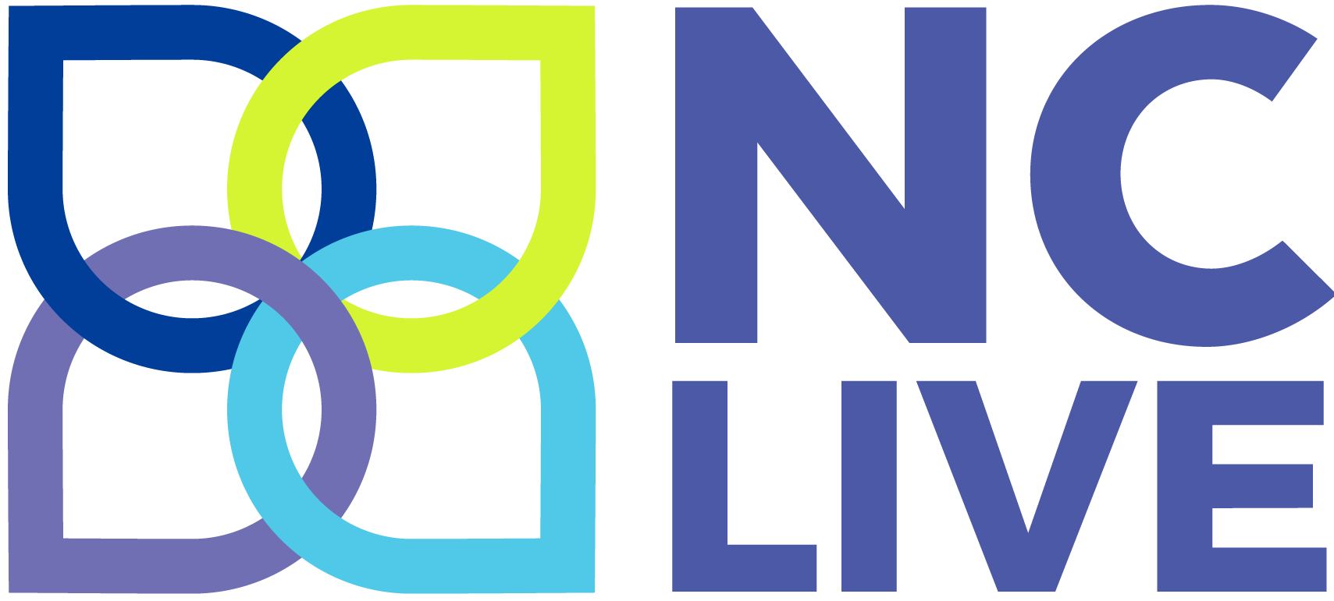Media Contact:

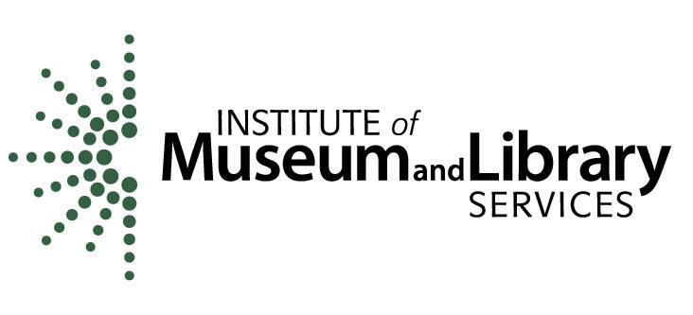

Kim Henze, NC LIVE

[kim@nclive.org](mailto:kim@nclive.org)

919-513-3236

FOR IMMEDIATE RELEASE

**NC LIVE to address rising college textbook costs**

**RALEIGH, N.C. — June 14, 2018 —** The average yearly cost of college textbooks is now $1,200. For many first-generation and lower income students, this presents a dilemma: pay for textbooks or pay for rent, food, or gas. Too often students must choose between their academic success and meeting basic needs. In order to address this problem, educators have begun creating and adopting open, free e-textbooks for the most common college courses. These textbooks are available to students at no cost, ensuring that every student has an equal opportunity to succeed in the classroom, regardless of their financial status.

NC LIVE, North Carolina’s library cooperative, is launching a statewide initiative called Open Education North Carolina to curate open textbooks for the most-frequently taught courses at North Carolina’s colleges and universities. In the first two years of the initiative, NC LIVE and its partners will assess and select open textbooks for 30 courses, saving students approximately $1.5 million dollars.

Every North Carolina student is required to take general education courses like Psychology, Sociology, Public Speaking, Statistics, and Expository Writing, making these courses a top priority. “The potential savings to students are staggering,” explained Rob Ross, Executive Director of NC LIVE. “Imagine replacing a commercial textbook for just one required course. About 80,000 students took General Psychology last year in North Carolina. At $125 per book, that’s $10 million dollars that students don’t need to be paying.”

The financial pressure of tuition, fees, room and board can make it difficult or impossible for students to afford expensive commercial textbooks. Many students attempt to share a textbook, buy an outdated edition, or simply go without, jeopardizing their chances of performing well in class. “Community colleges are focused on lowering barriers to higher education access, and Open Education North Carolina addresses one of those barriers – cost,” said Peter Hans, President of the NC Community College System. “This effort will lower costs while upholding the standards of quality that students expect.”

Faculty adoption will be critical to the initiative’s success. Many instructors are unfamiliar with the open textbook movement and have already invested time and energy designing courses around commercial textbooks. NC LIVE will be providing open textbook workshops to interested faculty across the state, as well as offering financial grants to instructors who choose to adopt an open textbook. Faculty members will continue to select the textbook they believe best supports learning, but having free, high-quality textbooks available will enable them to also factor cost into their decision. “Open Education North Carolina will help a larger pool of students across our institutions gain greater access to widely-used textbooks, which will have an important impact on student success,” said UNC System President Margaret Spellings. “Through open workshops that are a part of this initiative, faculty will be able to weigh student cost as a factor when choosing textbooks to assign to their classes.”

Similar initiatives in Georgia, Virginia, Oregon and Ohio have steadily gained in popularity with faculty and students alike. However, while these states have launched open textbook programs in response to state government mandates to reduce the cost of higher education, Open Education North Carolina is a grassroots effort led by North Carolina’s library community. “Librarians have always supported the academic success of students,” noted Ross. “This is an opportunity for librarians to demonstrate their value in a new way by reducing the cost of higher education.”

“This open textbook project will have a positive impact on all college students, especially first-generation and lower income students and it is an excellent example of the strong partnerships among our higher education sectors in North Carolina and with NC LIVE,” said Dr. Hope Williams, President of the North Carolina Independent Colleges & Universities.

The Open Education North Carolina initiative will begin July 1, 2018. It is partially supported by grant funds from the Institute of Museum and Library Services under the provisions of the federal Library Services and Technology Act as administered by the State Library of North Carolina, a division of the Department of Natural and Cultural Resources (IMLS grant number LS-00-18-0034-18). To learn more, visit [www.nclive.org/OENC](http://www.nclive.org/OENC).

**About NC LIVE**

NC LIVE, North Carolina’s state library consortium, offers electronic access to resources for all ages on topics ranging from careers, business, and investing, to health, history, and genealogy. All North Carolinians have access to NC LIVE's ebooks, audiobooks, videos, magazines, newspapers, journals, language-learning tools, and other online materials through local public libraries, community colleges, or college and university libraries and through [www.nclive.org](http://www.nclive.org/).

**About the Institute of Museum and Library Services**

The Institute of Museum and Library Services is the primary source of federal support for the nation’s approximately [120,000 libraries](http://www.ala.org/tools/libfactsheets/alalibraryfactsheet01) and [35,000 museums](https://www.imls.gov/research-evaluation/data-collection/museum-universe-data-file). Our mission is to inspire libraries and museums to advance innovation, lifelong learning, and cultural and civic engagement. Our grant making, policy development, and research help libraries and museums deliver valuable services that make it possible for communities and individuals to thrive. To learn more, visit [www.imls.gov](https://www.imls.gov/) and follow us on [Facebook](http://www.facebook.com/USIMLS) and [Twitter](http://www.twitter.com/us_imls).