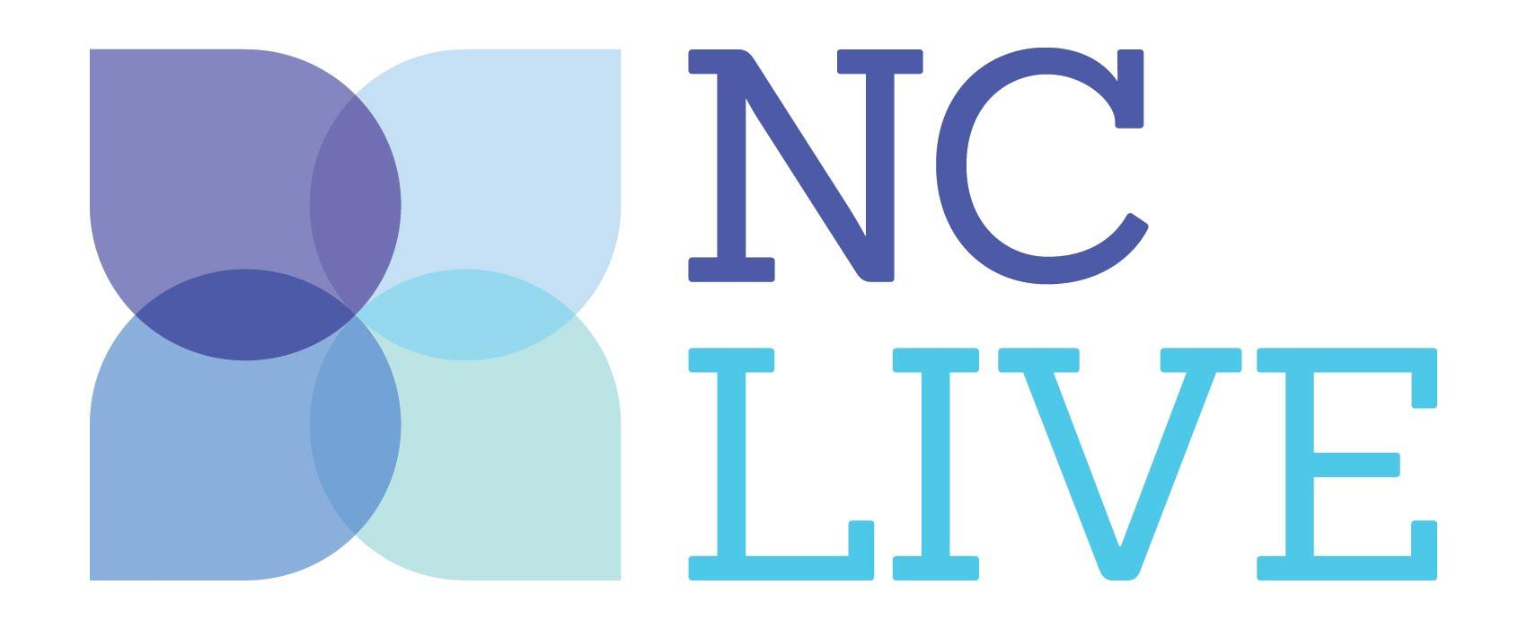
Media Contact:
Claire Leverett
Assistant Director
NC LIVE
NCSU Libraries, CB #7111
Raleigh, NC 27695
919-513-0449
claire@nclive.org

FOR IMMEDIATE RELEASE
December 12, 2016

UNC-TV’s North Carolina Bookwatch Joins the NC LIVE Online Collection

RALEIGH, NC—Season 18 of UNC-TV’s North Carolina Bookwatch is now available for free as part of the NC LIVE online collection at nclive.org. The 30-episode season features authors such as Scott Ellsworth, Bridgette Lacy, Lee Smith, Kathy Reichs, Pam Saulsby and more.

North Carolina Bookwatch is the state’s premier literary series, bringing the Tar Heel State’s best and brightest Southern writers to the small screen. In every interview, host D.G. Martin sheds light on authors’ lives, books and the state’s indelible imprint on their works.

NC LIVE is a statewide cooperative of 201 libraries that provides access to online articles, ebooks, streaming videos and digital newspapers. This content is purchased by libraries and available to all North Carolina residents who have a library card.

“As an extension of the University of North Carolina system, UNC-TV serves North Carolinians as the state's largest classroom—and NCLIVE serves citizens as our state's largest online library. North Carolina Bookwatch and NC LIVE—it’s an obvious and natural fit,” says Katy Loebrich, Producer/Director of the show. "Through a conversation with leaders at the State Library Network, North Carolina Bookwatch creator, host and tireless promoter D.G. Martin and I realized what a powerful resource NC LIVE offers to lifelong learners, whatever their age, in our state."

“NC LIVE is delighted to add North Carolina Bookwatch content to our collection of online resources,” says Rob Ross, NC LIVE’s Executive Director. “All told, the NC LIVE collection now consists of 483+ million online articles, streaming videos, ebooks and more.”

UNC-TV is committed to making educational and entertaining media available to all of North Carolina citizens and this new relationship with NC LIVE allows the network to do that in an exciting, new way.

To access the North Carolina Bookwatch episodes, use the search box on the NC LIVE homepage, nclive.org. For specific episodes, search for the author’s name or browse all Season 18 episodes by searching “North Carolina Bookwatch.” On the search results page, the links to the North Carolina Bookwatch episodes are listed by title in the lower right-hand corner of the screen in the "videos" box. Clicking the title will take you directly to the video on UNC-TV’s website, unctv.org.
About UNC-TV
UNC-TV provides people of all ages with enriching, life-changing television through its distinctive array of programs and services, including four digital channels: flagship UNC-TV—PBS & More, UNC-EX—The Explorer Channel, ROOTLE—UNC-TV's Kids Channel and the North Carolina Channel—Stories with a Local Accent. UNC-TV’s 12 stations comprise North Carolina’s only statewide television network, made possible through a unique partnership of public investment and private support. UNC-TV is committed to producing, broadcasting and sharing content for and about North Carolina, making it the state’s most important source of information about North Carolina. For more, visit UNCTV.org and join the conversation by liking us at facebook.com/unctv and following us @unctv on Twitter.

—unctv.org—

About NC LIVE
NC LIVE’s mission is to help libraries to support education, enhance economic development and improve quality of life. Founded in 1997, NC LIVE offers free electronic access to resources for all ages on topics ranging from careers, business and investing, to health, history and genealogy. NC LIVE’s thoughtfully curated e-books, audiobooks, videos, magazines, newspapers, journals, language-learning tools and other materials are designed for at-home use and available to all North Carolinians from any internet connection via local public library, community college and college and university library websites, or through nclive.org.

—nclive.org—

